**Assignemnt # 5**

**Part 1: Transform Operation**

**1)** This project aims to explore the relationship between spatial and frequency domains in different images. Apply DFT on the following images and plot their magnitudes. You may use Log and Shifted version for better comparison. Can we assign frequency responses to the images intuitively?

(**Hint**: use *fft2, fftshift*  commands in MATLAB)

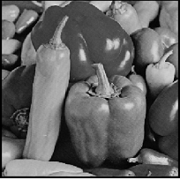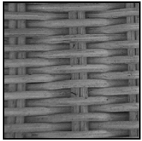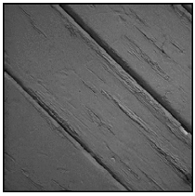

**2)** One application of Low-pass filter is noise reduction. However, it has adverse effect on the image edges and may cause Ring effect. To mitigate the aforementioned issues, Butterworth and Gaussian filters have been proposed. Use the image below and apply the following filters.

**a)** Apply Ideal low-pass filter and change its parameters and explain the results on the image edges.

**b)** Apply Butterworth low-pass filter and change its parameters to compare the results with the ideal filter.

**c)** Apply Gaussian low-pass filter and change its parameters to compare the results with the ideal and Butterworth filters.

(**Hint**: use *lpfilter*  MATLAB command).

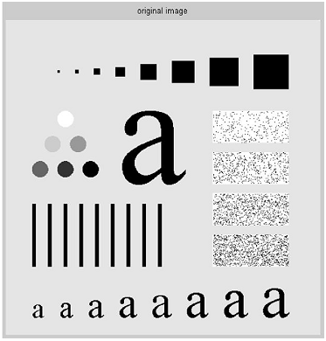

**3)** Repeat question 2 with the following high-pass filters.

**a)** Ideal filter **b)** Butterworth filter **c)** High-frequency-emphasis of Butterworth filter **d)** Gaussian filter

(**Hint**: use *hpfilter*  MATLAB command).

**Part 2: Morphological Image Processing**

**1)** **a)** Write a computer program capable of performing binary dilation and erosion with an arbitrary structuring element (SE) of size 3 x 3 that can be specified by the user.

**b)** Compare your results in part a) with *imdilate, imerode*  commands in MATLAB.

**2)** The aim of this project is to explore the role of structuring element on the output image.

Consider the following simple binary image. Apply morphological dilation with different structuring elements and different sizes. (**Hint**: use *imdilate, strel*  MATLAB commands).

Image=[00000;01100;01100;00100;00000]

**3)** Consider a simple binary image and perform the following compound morphological operations.

**a)** opening **b)** closing **c)** hit-or-miss

(**Hint**: use *imopen, imclose, bwhitmiss*  MATLAB commands).

**4)** Consider the image a) and use morphological operations to perform:

**a)** Count the number of blobs in the image. (**Hint**: use *bwlabel,* *bwselect*  MATLAB commands)

**b)** Which morphological operations should be employed to get images b, c, and d? Verify your answer.

